Question1 )

public class q1 {  
 public static void main(String[] args) {  
 double purchase = Double.*parseDouble*(args[0]);  
 double discount,total;  
  
 discount = (purchase >5000)? 0.1:0.05;  
  
 System.*out*.println("The purchase amount: "+purchase);  
 System.*out*.println("The discount applied: "+(purchase\*discount));  
 System.*out*.println("The final amount after applying the discount: "+(purchase-(purchase\*discount)));  
   
 }  
}

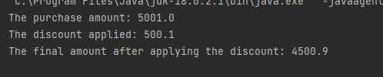

Question 2)

public class q2 {  
 public static void main(String[] args) {  
 String txt = "Welcome to Java Programming";  
 int length= txt.length();  
 System.*out*.println("Text Length is: "+length);  
   
 }  
}



Question 3)

public class q3 {  
 public static void main(String[] args) {  
 String first = "Hello, ";  
 String second = "World!";  
 System.*out*.println(first+second);  
 System.*out*.println(first.concat(second));  
 System.*out*.printf("%s%s",first,second);  
  
 }  
}

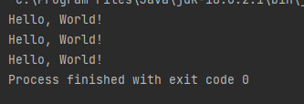

Question 4)

public class q4 {  
 public static void main(String[] args) {  
 String first = args[0];  
 String second = args[1];  
  
 boolean state= first.equals(second);  
  
 System.*out*.println("Two strings are equal: "+state);  
  
 }  
}



Question 5)

Output

s

sw

swoft

swiaroft

public class q5 {  
 public static void main(String[] args) {  
 String original ="software";  
 StringBuilder result = new StringBuilder("hi");  
 int index = original.indexOf('a');  
 result.setCharAt(0, original.charAt(0));  
 result.insert(1, original.charAt(4));  
 result.append(original.substring(1, 4));  
 result.insert(3, (original.substring(index, index+2) + ""));  
 System.*out*.println(result);  
  
  
 }  
}

output



Question 6)

public class q6 {  
 public static void main(String[] args) {  
  
 StringBuilder txt =new StringBuilder("Sample Text") ;  
 System.*out*.println("Reversed string: "+ txt.reverse());  
 }  
}



Question 7)

public class q7 {  
 public static void main(String[] args) {  
  
 String fName ="Kamala";  
 String mName ="Sugarcane";  
 String lName = "Perera";  
 int age = 20\*100;  
  
 StringBuffer password = new StringBuffer().append(fName.toLowerCase().charAt(0)).append(mName.substring(0,2).toLowerCase()).append(lName.substring((lName.length()-3),lName.length()-1).toLowerCase()).append(age);  
 System.*out*.println(password);  
  
 }  
}

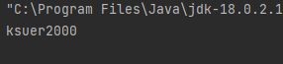

Question 8)

public class q8 {  
 enum WeatherCondition {  
 *SUNNY*, *RAINY*, *CLOUDY* }  
  
 public static void main(String[] args) {  
 WeatherCondition currentWeather = WeatherCondition.*RAINY*;   
  
 String activity = (currentWeather == WeatherCondition.*SUNNY*) ? "Go for a picnic." :  
 (currentWeather == WeatherCondition.*RAINY*) ? "Stay indoors and read a book." :  
 "Take a relaxing walk.";  
  
 System.*out*.println("The weather is " + currentWeather + ". " + activity);  
 }  
}



Question 9 a)

public class q9 {  
 public static void main(String[] args) {  
 String txt = "I'm a JaVa PrOgRaMmEr";  
  
 String h = txt.replaceAll("[mM]","");  
 System.*out*.println(h);  
  
  
 }  
}



9 b)

public class q10 {  
 public static void main(String[] args) {  
 String txt = "ICS 102: Introduction to Computing I";  
  
 String[] arr = txt.split(" ");  
 String[] sec =arr[1].split(":");  
 System.*out*.println("Course Name: "+arr[0]);  
 System.*out*.println("Course Number: "+sec[0]);  
 System.*out*.println("Course Description: "+arr[2]+" "+arr[3]+" "+arr[4]+" "+arr[5]);  
  
  
  
 }  
}

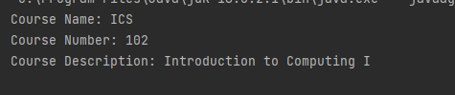

9 c)

public class q11 {  
 public static void main(String[] args) {  
 String txt1 = "Niroshan Perera";  
 String txt2 = "Kamal Alwis";  
  
 String[] txt1Split = txt1.split(" ");  
 String[] txt2Split = txt2.split(" ");  
 System.*out*.println(txt1Split[0]+" "+txt2Split[1]);  
 System.*out*.println(txt2Split[0]+" "+txt1Split[1]);  
  
  
  
 }  
}

